Name: <your name>

Project number: 21759407

IDE name: Eclipse Oxygen.3a Release (4.7.3a)

Operating system: Windows 10

Instructions to set-up and run project:

1. Changes done to the bookmarks project
   1. Added 1 radio button group, 1 checkbox, 1 list box
   2. Changed the graphical image from: Duke waving to: Duke thumbs up
   3. Added a table to the response page.

For more information on this, check Chapter 4, which contains detailed information about the changes.

1. Proof of compilation

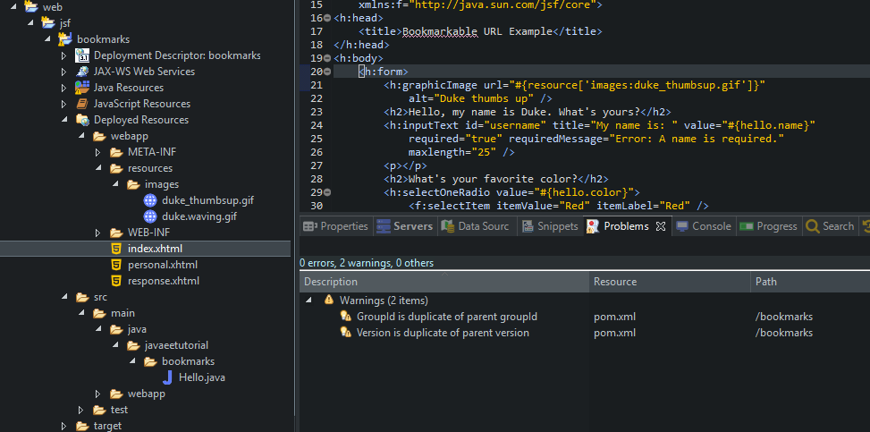

Figure Screenshot showing correct compilation of code

1. How it works:
   1. Select index.xhtml -> right-click -> Run-as -> Run on Server -> Glassfish
   2. Wait a few seconds for the server to start
   3. Go to your preferred browser and paste this address: <http://localhost:8080/bookmarks/index.xhtml>
   4. The index page now looks like this:

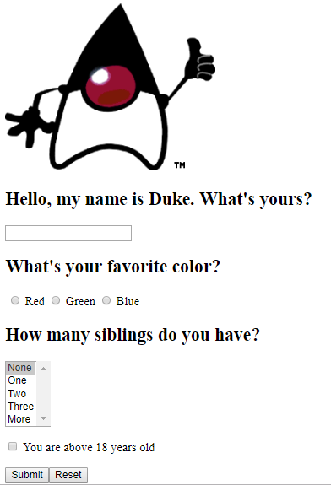

Figure The index page with added controls

* 1. Input the Name input box, select your favorite color in the radio, select the number of siblings in the list box, and check the checkbox whether you are above 18
  2. Press Submit
  3. The response page is displayed containing the data you input before. In addition, it contains some predefined grades in a table, at the bottom of the page.

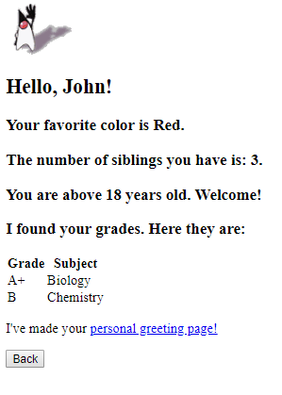

Figure Response page containing the information from the stating page

* 1. Press the ‘Personal greeting page’ link to go to the **Personal** page. You can see the same information in a different way

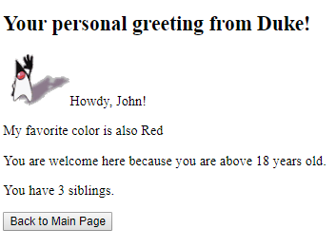

Figure Personal page containing the input information